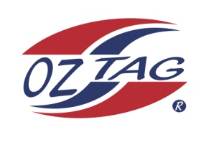
2022 TAMWORTH TAIPANS

UNDER 15 BOYS

Congratulations to the following players selected in the Tamworth Taipans
15’s Boys Junior Oztag Representative TEAM for 2022.

BOYS 15’s
Billy | Daly
Bryce | Walsh
Coby | Single
Deagan | Sippel
Fletcher | Panton
Harrison | Crowell
Harry | Gill
Josh | Beard
Kallen | Davis
Nick | Green
Oscar | Turner
Robbie | Naden
Robert | Murphy
Seth | Pearson
Toby | McIlveen
Zac | Spreadborough
SHADOW | PLAYER
Tanner | Crook
Toby | Robertson

- Coach: Adam Single
- Manager: Skye Single – 0417 444 661

- Congratulations, you have been selected in the Taipans Junior Oztag Representative TEAM to represent at the 2022 NSW Junior State Cup on Wednesday 1st & Thursday 2nd June 2022 to be held at Coffs Harbour.

- Please contact your Manager to accept your position in the team by Friday 11th February. Player Registration is $220. Registration is online & closes 20th February 2022.

- Go to https://www.oztagequipmentsupplies.com/

- Further information and Code of Conduct Form are on the Website. By nominating to play State Cup, you have agreed to abide by the Players Code of Conduct.

- There will be Compulsory training sessions commencing on March 13th. Your Manager will be in touch regarding times and venue

