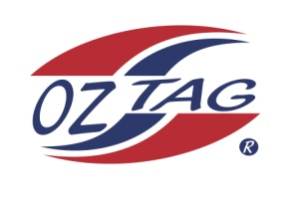
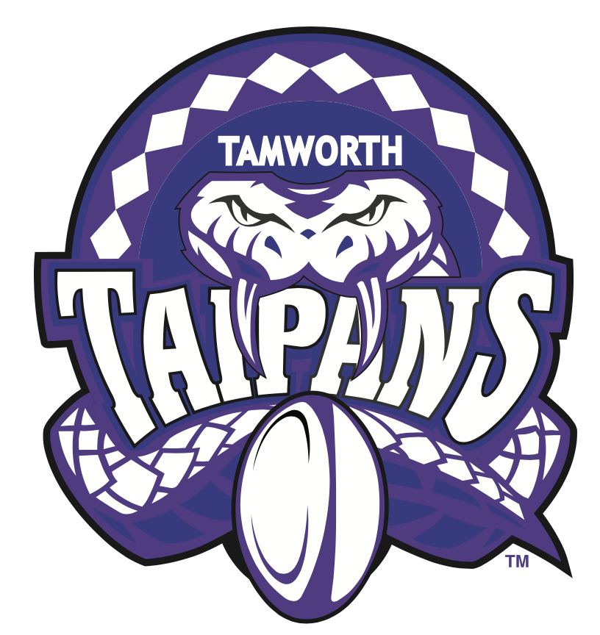
2022 TAMWORTH TAIPANS

UNDER 13 BOYS

Congratulations to the following players selected in the Tamworth Taipans
13’s Boys Junior Oztag Representative TEAM for 2022.

BOYS 13’s
Brody | Lace
Connor | Craig
Evan | Morrison
Harry | Hickey
Haydon | Allan Saunders
Henry | Gilbert
Issac | Stackman
Izaiah | Craigie
Kobhan | Nean
Lynx | Johnston
Nalani | Nean
Parker | O'Neile
Riley | Daly
Thomas | Ryan
William | Green

- Coach: Matt Nean
- Manager: Kirsty O’Neile – 0408 762 032

- Congratulations, you have been selected in the Taipans Junior Oztag Representative TEAM to represent at the 2022 NSW Junior State Cup on Wednesday 1st & Thursday 2nd June 2022 to be held at Coffs Harbour.

- Please contact your Manager to accept your position in the team by Friday 11th February. Player Registration is $220. Registration is online & closes 20th February 2022.

- Go to https://www.oztagequipmentsupplies.com/

- Further information and Code of Conduct Form are on the Website. By nominating to play State Cup, you have agreed to abide by the Players Code of Conduct.

- There will be Compulsory training sessions commencing on March 13th. Your Manager will be in touch regarding times and venue

