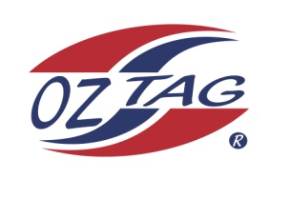
2022 TAMWORTH TAIPANS

UNDER 12 BOYS

Congratulations to the following players selected in the Tamworth Taipans
12’s Boys Junior Oztag Representative TEAM for 2022.

BOYS 12’s
Bowen | Strong
Bradie | Hatch
Brodie | Hatch
Bryce | Reidsmith
Chase | Patterson
Cooper | Rule
Corey | Lay
Issac | Wheeler
Jace | Single
Jacob | Howarth
Jiah | Kelly
Levi | Gebadi
Lewis | Crough
Myles | Taylor
Zaiden | Kelly
Zane | Perrett

- Coach: Lonnie Hatch
- Manager: Lasche Perrett – 0401 483 460

- Congratulations, you have been selected in the Taipans Junior Oztag Representative TEAM to represent at the 2022 NSW Junior State Cup on Saturday 4th & Sunday 5th June 2022 to be held at Coffs Harbour.

- Please contact your Manager to accept your position in the team by Friday 11th February. Player Registration is $220. Registration is online & closes 20th February 2022.

- Go to https://www.oztagequipmentsupplies.com/

- Further information and Code of Conduct Form are on the Website. By nominating to play State Cup, you have agreed to abide by the Players Code of Conduct.

- There will be Compulsory training sessions commencing on March 13th. Your Manager will be in touch regarding times and venue

