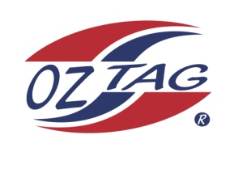
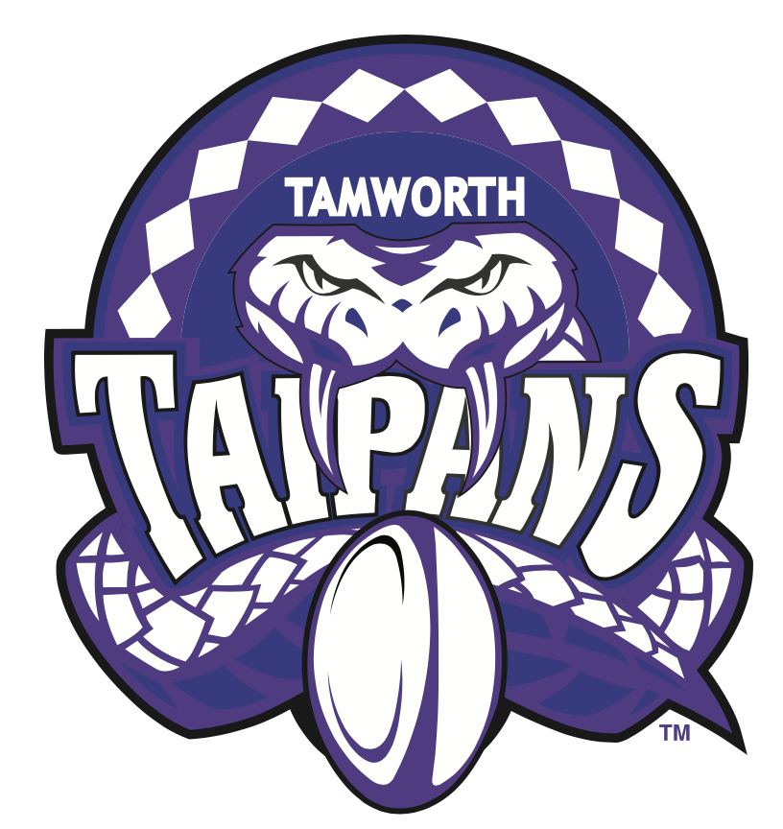
2022 TAMWORTH TAIPANS

UNDER 11 BOYS
Congratulations to the following players selected in the Tamworth Taipans
11’s Boys Junior Oztag Representative TEAM for 2022.

 | BOYS 11’s
Archie |  | Mitchell
Ashton |  | Jones
Brooklyn |  | Le Brocq-Watton
Chase |  | McKay
Chayse |  | Riley
Easton |  | Battle
Eli |  | Harrison
Jack |  | Clinton
Jaiden |  | Wright
Kade |  | Crittenden
Kalen |  | Loveday
Maximus |  | Thompson
Mitch |  | Weekes
Parker |  | Beaton
Tyler |  | O'Neile
Xavier |  | Parris
SHADOW |  | PLAYERS
Jett |  | Martin
Matther |  | Murphy

- Coach: James Cooper & Andrew Loveday
- Manager: Jon Weekes – 0429 400 789

- Congratulations, you have been selected in the Taipans Junior Oztag Representative TEAM to represent at the 2022 NSW Junior State Cup on Saturday 4th & Sunday 5th June 2022 to be held at Coffs Harbour.

- Please contact your Manager to accept your position in the team by Friday 11th February. Player Registration is $220. Registration is online & closes 20th February 2022.

- Go to https://www.oztagequipmentsupplies.com/

- Further information and Code of Conduct Form are on the Website. By nominating to play State Cup, you have agreed to abide by the Players Code of Conduct.

- There will be Compulsory training sessions commencing on March 13th. Your Manager will be in touch regarding times and venue

