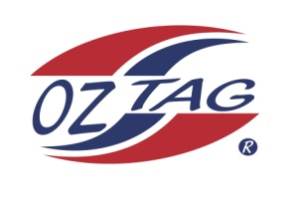
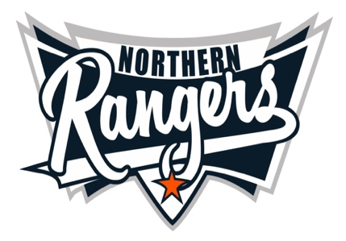
2021 NORTHERN RANGERS

UNDER 15 BOYS

Congratulations to the following players selected in the Northern Rangers
15 Boys Junior Oztag Representative TEAM for 2021.

15 BOYS
NAME | ASSOCIATION
Bailey Asbury | Port Macquarie
Blake Patterson | Tamworth
Brodhi Davis | Tamworth
Brodhie Newman | Port Macquarie
Bryce Rampling | Tamworth
Cohen Model | Port Macquarie
Cooper Anderson | Tamworth
Jacob Cooper | Port Macquarie
Kayden Jones-Moore | Port Macquarie
Louis Barry | Port Macquarie
Max Eggert | Port Macquarie
Noah Model | Port Macquarie
Raff Ryan | Port Macquarie
Tayte Gibson | Port Macquarie
Will Heeney | Port Macquarie

IMPORTANT INFORMATION

- Coach: Troy Newman 0411 598 546
- Manager: John Eggert 0418 660 125

- The 2021 Australian Titles on Friday 10th, Saturday 11th and Sunday 12th December, 2021 to be held at Coffs Harbour. Players are to arrange their own accommodation and transport.

- Please text your manager with confirmation of selection by August 5th.
- Don’t forget to include your name.

- Training date and venue will be confirmed shortly.

- All players MUST pay the full cost $220 online at the following link,

https://www.oztagequipmentsupplies.com/rangers BY Aug 10th.

- See ‘Representative’ tab for further details on your association website.
https://tamworthjuniors.oztag.com.au/northern-rangers/

- Additional merchandise can be ordered when making payment online.

