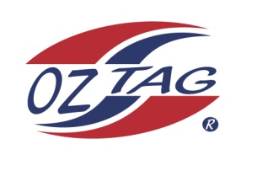
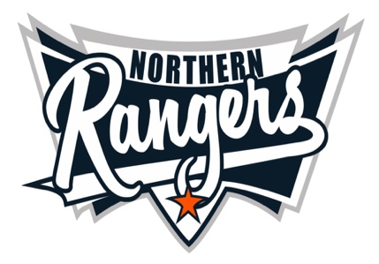
2021 NORTHERN RANGERS

UNDER 9 GIRLS

Congratulations to the following players selected in the Northern Rangers
9 Girls Junior Oztag Representative TEAM for 2021.

9 GIRLS
NAME | ASSOCIATION
Addison Lockyer | Tamworth
Audrey Gilbert | Tamworth
Azarlee Ramirez | Tamworth
Caitlyn Downey | Tamworth
Dakota Ferguson | Tamworth
Darcie Perrett | Tamworth
Ellieanna Kelly | Tamworth
Hallie Green | Tamworth
Harmony Lamb | Tamworth
Indy Single | Tamworth
Isabelle Scanlon | Tamworth
Lily Porter | Tamworth
Savannah Brazier | Tamworth
Stella Walsh | Tamworth

IMPORTANT INFORMATION

- Coach: Tim Walsh 0407 460 895
- Manager: TBC

- The 2021 Australian Titles on Friday 15th, Saturday 16th and Sunday 17th October, 2021 to be held at Coffs Harbour. Players are to arrange their own accommodation and transport.

- Please text your coach with confirmation of selection by July 25th.
- Don’t forget to include your name.

- Trainings will be Sunday’s at Riverside Fields Tamworth, 9am -11am starting 15th August.
(Coaches may choose to commence earlier, please notify Katrina)

- Compulsory trainings are 22nd August and 5th September, 10.30am – 1pm.
- All players MUST pay the full cost $220 online at the following link,

https://www.oztagequipmentsupplies.com/rangers BY Aug 10th.

- See ‘Representative’ tab for further details on your association website.
https://tamworthjuniors.oztag.com.au/northern-rangers/

- Additional merchandise can be ordered when making payment online.

