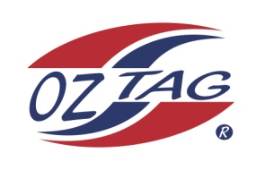
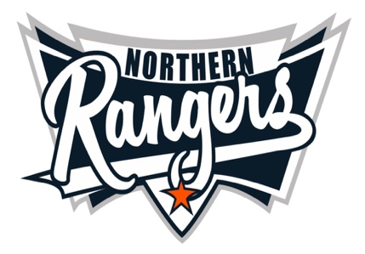
2021 NORTHERN RANGERS

UNDER 17 GIRLS

Congratulations to the following players selected in the Northern Rangers
17 Girls Junior Oztag Representative TEAM for 2021.

17 GIRLS
NAME | ASSOCIATION
Abby Bowden | Tamworth
Ainsley Dominick | Tamworth
Alexis Coglan | Port Macquarie
Alyssa Davis | Tamworth
Annalise Tighe | Tamworth
Cienna McKeogh | Port Macquarie
Emma Allen | Tamworth
Grace Edgecock | Tamworth
Isabella Keegan | Port Macquarie
Jordan Guest | Port Macquarie
Katelyn Atkins | Tamworth
Kynesha Fuller | Tamworth
Madison Coglan | Port Macquarie
Monique Corbett | Tamworth
Piper Stevens | Port Macquarie
Shelby Filipek | Port Macquarie

IMPORTANT INFORMATION

- Coach: Steve Corbett/ Chris Cartan
- Manager: Peita Corbett 0409 474 003

- The 2021 Australian Titles on Friday 15th, Saturday 16th and Sunday 17th October, 2021 to be held at Coffs Harbour. Players are to arrange their own accommodation and transport.

- Please text your manager with confirmation of selection by July 25th.
- Don’t forget to include your name.

- Trainings will be Sunday’s at Riverside Fields Tamworth, 9am -11am starting 15th August.
(Coaches may choose to commence earlier, please notify Katrina)

- Compulsory trainings are 22nd August and 5th September, 10.30am – 1pm.

- All players MUST pay the full cost $220 online at the following link,

https://www.oztagequipmentsupplies.com/rangers BY Aug 10th.

- See ‘Representative’ tab for further details on your association website.
https://tamworthjuniors.oztag.com.au/northern-rangers/

- Additional merchandise can be ordered when making payment online.

