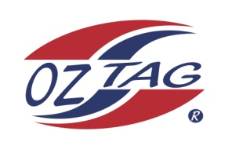
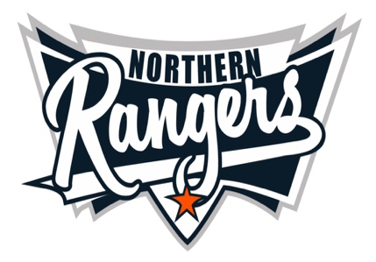
2021 NORTHERN RANGERS

UNDER 17 BOYS

Congratulations to the following players selected in the Northern Rangers
17 Boys Junior Oztag Representative SQUAD for 2021.

*17 BOYS
NAME | ASSOCIATION
Bailey Wills | Tamworth
Bailey Wolridge | Tamworth
Byron Lees | Tamworth
Jack Edser | Tamworth
Jack Murdoch | Tamworth
Jackson Swalwell | Tamworth
Jacob Bird | Tamworth
Keatin Nowak | Port Macquarie
Kobe Roser | Port Macquarie
Lachlan McDonald | Tamworth
Logan Burkett | Tamworth
Matthew Brindley | Tamworth
Mitchel Wilson | Tamworth
Nash Porter | Tamworth
Nathaniel Follington | Tamworth
Robbie Lay | Tamworth
Toby Lloyd | Tamworth
William Thompson | Tamworth
Zac Walters | Tamworth

IMPORTANT INFORMATION

- Coach: Daniel Sullivan 0422 440 500
- Manager: Mandy Sullivan

- The 2021 Australian Titles on Friday 15th, Saturday 16th and Sunday 17th October, 2021 to be held at Coffs Harbour. Players are to arrange their own accommodation and transport.

- Please text your coach with confirmation of selection by July 25th.
- Don’t forget to include your name.

- Trainings will be Sunday’s at Riverside Fields Tamworth, 9am -11am starting 15th August.
(Coaches may choose to commence earlier, please notify Katrina)

- Compulsory trainings are 22nd August and 5th September, 10.30am – 1pm.

- All players MUST pay the full cost $220 online at the following link,

https://www.oztagequipmentsupplies.com/rangers BY Aug 10th.

- See ‘Representative’ tab for further details on your association website.
https://tamworthjuniors.oztag.com.au/northern-rangers/

- Additional merchandise can be ordered when making payment online.

