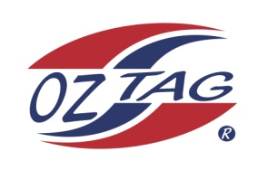
2021 NORTHERN RANGERS

UNDER 14 GIRLS

Congratulations to the following players selected in the Northern Rangers
14 Girls Junior Oztag Representative TEAM for 2021.

14 GIRLS
NAME | ASSOCIATION
Makenna Barnett-Suey | Tamworth
Shelby Rapley | Tamworth
Lillian Rapley | Tamworth
Sharni Graham | Port Macquarie
Emilee Franklin | Port Macquarie
Charlee Bailey | Port Macquarie
Emma Wheeler | Port Macquarie
Savannah Nowak | Port Macquarie
Penelope Sprague | Port Macquarie
Indyannah Craigie | Tamworth
Elle Beaumont | Tamworth
Maya Patterson | Tamworth
Tylana Lamb | Tamworth
Talia Marsh | Port Macquarie
Jasmine Hurley | Port Macquarie
Indy Brazier | Tamworth

IMPORTANT INFORMATION

- Coach: Emma Nowak 0419 048 898
- Manager: TBC

- The 2021 Australian Titles on Friday 15th, Saturday 16th and Sunday 17th October, 2021 to be held at Coffs Harbour. Players are to arrange their own accommodation and transport.

- Please text your coach with confirmation of selection by July 25th.
- Don’t forget to include your name.

- Trainings will be Sunday’s at Riverside Fields Tamworth, 9am -11am starting 15th August.
(Coaches may choose to commence earlier, please notify Katrina) (TAMWORTH GIRLS TO JOIN WITH 15’S)

- Compulsory trainings are 22nd August, IN PORT MACQUARIE and 5th September IN TAMWORTH, 10.30am – 1pm.

- All players MUST pay the full cost $220 online at the following link,

https://www.oztagequipmentsupplies.com/rangers BY Aug 10th.

- See ‘Representative’ tab for further details on your association website.
https://tamworthjuniors.oztag.com.au/northern-rangers/

- Additional merchandise can be ordered when making payment online.

