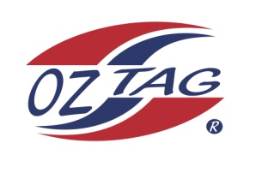
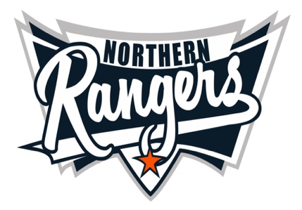
2021 NORTHERN RANGERS

UNDER 14 BOYS

Congratulations to the following players selected in the Northern Rangers
14 Boys Junior Oztag Representative TEAM for 2021.

14 BOYS
NAME | ASSOCIATION
Billy Daly | Tamworth
Coby Single | Tamworth
Cooper Peterson | Tamworth
Deagan Sipple | Tamworth
Fletcher Panton | Tamworth
Harrison Crowell | Tamworth
Harry Gill | Tamworth
Jacob Queripel | Port Macquarie
Josh Beard | Tamworth
Nicholas Green | Tamworth
Oscar Turner | Tamworth
Robert Naden | Tamworth
Ryan Rankin | Tamworth
Toby McIlveen | Tamworth
SHADOW PLAYERS
Cody Baxter | Tamworth
Kallen Davis | Tamworth

IMPORTANT INFORMATION

- Coach: Adam Single/ Matt Panton
- Manager: Skye Single 0417 444 661

- The 2021 Australian Titles on Friday 15th, Saturday 16th and Sunday 17th October, 2021 to be held at Coffs Harbour. Players are to arrange their own accommodation and transport.

- Please text your manager with confirmation of selection by July 25th.
- Don’t forget to include your name.

- Trainings will be Sunday’s at Riverside Fields Tamworth, 9am -11am starting 15th August.
(Coaches may choose to commence earlier, please notify Katrina)

- Compulsory trainings are 22nd August and 5th September, 10.30am – 1pm.

- All players MUST pay the full cost $220 online at the following link,

https://www.oztagequipmentsupplies.com/rangers BY Aug 10th.

- See ‘Representative’ tab for further details on your association website.
https://tamworthjuniors.oztag.com.au/northern-rangers/

- Additional merchandise can be ordered when making payment online.

