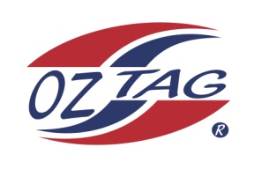
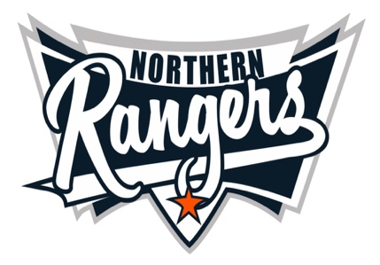
2021 NORTHERN RANGERS

UNDER 13 GIRLS

Congratulations to the following players selected in the Northern Rangers
13 Girls Junior Oztag Representative TEAM for 2021.

13 GIRLS
NAME | ASSOCIATION
Ava Harrison | Tamworth
Bridget Stackman | Tamworth
Chelsea Atkins | Tamworth
Cordelia Wilson | Tamworth
Delika Boney | Tamworth
Grace Smith | Port Macquarie
Hannah Detmers | Tamworth
Isabella Howarth | Tamworth
Janae Griffiths | Tamworth
Mackenzie Perrett | Tamworth
Mikayla Skinner | Tamworth
Sehtaya Gordon | Port Macquarie
Zahlee Betts | Tamworth

IMPORTANT INFORMATION

- Coach: Shane Howarth
- Manager: Tracy Howarth 0447 884 333

- The 2021 Australian Titles on Friday 15th, Saturday 16th and Sunday 17th October, 2021 to be held at Coffs Harbour. Players are to arrange their own accommodation and transport.

- Please text your manager with confirmation of selection by July 25th.
- Don’t forget to include your name.

- Trainings will be Sunday’s at Riverside Fields Tamworth, 9am -11am starting 15th August.
(Coaches may choose to commence earlier, please notify Katrina)

- Compulsory trainings are 22nd August and 5th September, 10.30am – 1pm.

- All players MUST pay the full cost $220 online at the following link,

https://www.oztagequipmentsupplies.com/rangers BY Aug 10th.

- See ‘Representative’ tab for further details on your association website.
https://tamworthjuniors.oztag.com.au/northern-rangers/

- Additional merchandise can be ordered when making payment online.

