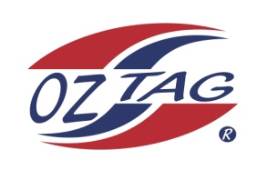
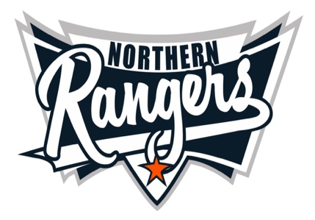
2021 NORTHERN RANGERS

UNDER 12 GIRLS

Congratulations to the following players selected in the Northern Rangers
12 Girls Junior Oztag Representative TEAM for 2021.

12 GIRLS
NAME | ASSOCIATION
Ella Hatch | Tamworth
Evy Walsh | Tamworth
Jaime Grobler | Tamworth
Jasmine Harris | Tamworth
Lara Cartan | Tamworth
Layla Thomas | Tamworth
Lillian Rule | Tamworth
Miley Smith | Tamworth
Olivia Murray | Tamworth
Shayliana Reid | Tamworth
Sienna Pepperell | Tamworth
Sarah Bird | Tamworth
Zoe Sullivan | Tamworth

IMPORTANT INFORMATION

- Coach: Tiffany Walsh
- Manager: Mandy Sullivan 0411 460 895

- The 2021 Australian Titles on Friday 15th, Saturday 16th and Sunday 17th October, 2021 to be held at Coffs Harbour. Players are to arrange their own accommodation and transport.

- Please text your manager with confirmation of selection by July 25th.
- Don’t forget to include your name.

- Trainings will be Sunday’s at Riverside Fields Tamworth, 9am -11am starting 15th August.
(Coaches may choose to commence earlier, please notify Katrina)

- Compulsory trainings are 22nd August and 5th September, 10.30am – 1pm.

https://www.oztagequipmentsupplies.com/rangers BY Aug 10th.

- See ‘Representative’ tab for further details on your association website.
https://tamworthjuniors.oztag.com.au/northern-rangers/

- Additional merchandise can be ordered when making payment online.

