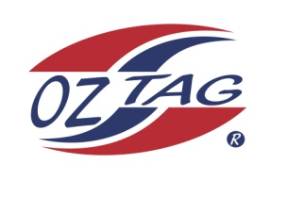
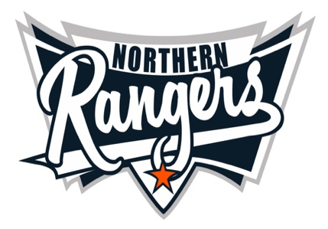
2021 NORTHERN RANGERS

UNDER 12 BOYS

Congratulations to the following players selected in the Northern Rangers
12 Boys Junior Oztag Representative TEAM for 2021.

12 BOYS
NAME | ASSOCIATION
Brody Lace | Tamworth
Connor Craig | Tamworth
Evan Morrison | Tamworth
Hayden Allan-Saunders | Tamworth
Henry Gilbert | Tamworth
Isaac Stackman | Tamworth
Izaiah Craigie | Tamworth
Jake Keegan | Port Macquarie
Kobhan Nean | Tamworth
Luca Johnson | Port Macquarie
Nalani Nean | Tamworth
Parker O’Neile | Tamworth
Rafferty Gordon | Port Macquarie
Riley Daly | Tamworth
Thomas Ryan | Tamworth
William Green | Tamworth
SHADOW Alex Sear | Port Macquarie
SHADOW Kobi McMaster | Tamworth

IMPORTANT INFORMATION

- Coach: Matt Nean
- Manager: Kirsty O’Neile 0408 762 032

- The 2021 Australian Titles on Friday 15th, Saturday 16th and Sunday 17th October, 2021 to be held at Coffs Harbour. Players are to arrange their own accommodation and transport.

- Please text your manager with confirmation of selection by July 25th.
- Don’t forget to include your name.

- Trainings will be Sunday’s at Riverside Fields Tamworth, 9am -11am starting 15th August.
(Coaches may choose to commence earlier, please notify Katrina)
- Compulsory trainings are 22nd August and 5th September, 10.30am – 1pm.

- All players MUST pay the full cost $220 online at the following link,

https://www.oztagequipmentsupplies.com/rangers BY Aug 10th.

- See ‘Representative’ tab for further details on your association website.
https://tamworthjuniors.oztag.com.au/northern-rangers/

- Additional merchandise can be ordered when making payment online.

