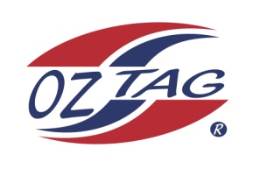
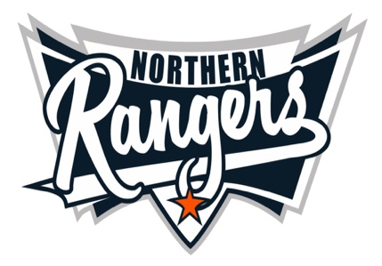
2021 NORTHERN RANGERS

UNDER 11 GIRLS

Congratulations to the following players selected in the Northern Rangers
11 Girls Junior Oztag Representative TEAM for 2021.

11 GIRLS
NAME | ASSOCIATION
Holly McIlveen | Tamworth
Phoebe Jobson | Tamworth
Anika Boney | Tamworth
Isabel O’Connell | Tamworth
Samaya Davis | Tamworth
Jacinta-Dean Hoffman | Tamworth
Natalie Nean | Tamworth
Phoebe Wiegold | Tamworth
Marlie Wilson | Tamworth
Ebony Pepperell | Tamworth
Brodie Burrows | Tamworth
Mia Naden | Tamworth
Summar Barnett | Tamworth
Marley Cowley | Tamworth
SHADOWS
Chloe McLuand | Tamworth
Sienna Caslick | Tamworth

IMPORTANT INFORMATION

- Coach: Todd Wilson 0404 081 352
- Manager: Liz Kelly 0422 791 029

- The 2021 Australian Titles on Friday 15th, Saturday 16th and Sunday 17th October, 2021 to be held at Coffs Harbour. Players are to arrange their own accommodation and transport.

- Please text your manager with confirmation of selection by July 20th.
- Don’t forget to include your name.

- Trainings will be Sunday’s at Riverside Fields Tamworth, 9am -11am starting 15th August.
(Coaches may choose to commence earlier, please notify Katrina)

- Compulsory trainings are 22nd August and 5th September, 10.30am – 1pm.

- All players MUST pay the full cost $220 online at the following link,

https://www.oztagequipmentsupplies.com/rangers BY Aug 10th.

- See ‘Representative’ tab for further details on your association website.
https://tamworthjuniors.oztag.com.au/northern-rangers/

- Additional merchandise can be ordered when making payment online.

