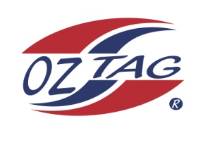
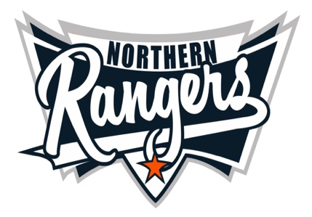
2021 NORTHERN RANGERS

UNDER 11 BOYS

Congratulations to the following players selected in the Northern Rangers
11 Boys Junior Oztag Representative TEAM for 2021.

11 BOYS
NAME | ASSOCIATION
Bowen Strong | Tamworth
Bradie Hatch | Tamworth
Brodie Hatch | Tamworth
Bryce Reid Smith | Tamworth
Chase Patterson | Tamworth
Cooper Rule | Tamworth
Isaac Wheeler | Tamworth
Jace Single | Tamworth
Jacob Howarth | Tamworth
Jayden Baker | Tamworth
Jiah Kelly | Tamworth
Lewis Crough | Tamworth
Mason Nowak | Port Macquarie
Zaiden Kelly | Tamworth
Zane Perrett | Tamworth

IMPORTANT INFORMATION

- Coach: Lonnie Hatch
- Manager: Lasche Perrett 0401 483 460

- The 2021 Australian Titles on Friday 15th, Saturday 16th and Sunday 17th October, 2021 to be held at Coffs Harbour. Players are to arrange their own accommodation and transport.

- Please text your manager with confirmation of selection by July 25th.
- Don’t forget to include your name.

- Trainings will be Sunday’s at Riverside Fields Tamworth, 9am -11am starting 15th August.
(Coaches may choose to commence earlier, please notify Katrina)

- Compulsory trainings are 22nd August and 5th September, 10.30am – 1pm.

- All players MUST pay the full cost $220 online at the following link,

https://www.oztagequipmentsupplies.com/rangers BY Aug 10th.

- See ‘Representative’ tab for further details on your association website.
https://tamworthjuniors.oztag.com.au/northern-rangers/

- Additional merchandise can be ordered when making payment online.

