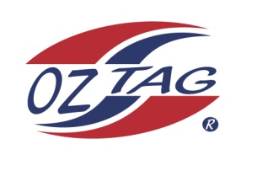
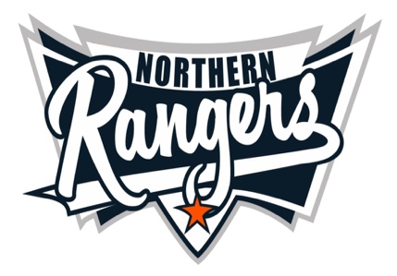
2021 NORTHERN RANGERS

UNDER 10 GIRLS

Congratulations to the following players selected in the Northern Rangers
10 Girls Junior Oztag Representative TEAM for 2021.

10 GIRLS
NAME | ASSOCIATION
Addison Grobler | Tamworth
Armani Daley | Port Macquarie
Armanii Ramirez | Tamworth
Cobie Rowling-Wrigley | Tamworth
Emily Barratt | Tamworth
Harper Thomas | Tamworth
Kelsea Lamb | Tamworth
Kyharni Beale-Smith | Tamworth
Maysa Davis | Tamworth
Mia Watson | Tamworth
Milla Panton | Tamworth
Rylee Perrett | Tamworth
Sienna Ferguson | Tamworth
Sophie Martin | Tamworth

IMPORTANT INFORMATION

- Coach: Krystal Lamb
- Manager: Renee Leigh 0456 883 973

- The 2021 Australian Titles on Friday 15th, Saturday 16th and Sunday 17th October, 2021 to be held at Coffs Harbour. Players are to arrange their own accommodation and transport.

- Please text your manager with confirmation of selection by July 25th.
- Don’t forget to include your name.

- Trainings will be Sunday’s at Riverside Fields Tamworth, 9am -11am starting 15th August.
(Coaches may choose to commence earlier, please notify Katrina)

- Compulsory trainings are 22nd August and 5th September, 10.30am – 1pm.

- All players MUST pay the full cost $220 online at the following link,

https://www.oztagequipmentsupplies.com/rangers BY Aug 10th.

- See ‘Representative’ tab for further details on your association website.
https://tamworthjuniors.oztag.com.au/northern-rangers/

- Additional merchandise can be ordered when making payment online.

