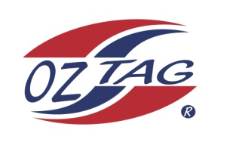
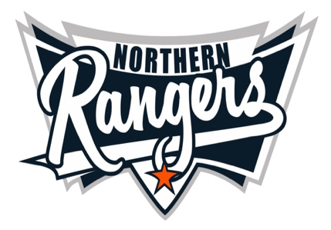
2021 NORTHERN RANGERS

UNDER 9 BOYS

Congratulations to the following players selected in the Northern Rangers
9 Boys Junior Oztag Representative TEAM for 2021.

9 BOYS
NAME | ASSOCIATION
Archie Taylor | Tamworth
Ashton Skuthorpe | Tamworth
Ben Van Aanholt | Tamworth
Cohen Jones | Tamworth
Cooper Porter | Tamworth
Jaxon Craig | Tamworth
Kade Strong | Tamworth
Kobe-Jack Lillicrap | Tamworth
Koby Wilson | Tamworth
Mason Duffy | Port Macquarie
Nate Wilson | Tamworth
Nicholas Nean | Tamworth
Teo Starr | Tamworth
Zephaniah Munro | Tamworth
SHADOW Billy Jones | Tamworth
SHADOW Oscar McMurtrie | Tamworth

IMPORTANT INFORMATION

- Coach: Pat Strong
- Manager: Felicity Van Aanholt 0413 921 810

- The 2021 Australian Titles on Friday 15th, Saturday 16th and Sunday 17th October, 2021 to be held at Coffs Harbour. Players are to arrange their own accommodation and transport.

- Please text your manager with confirmation of selection by July 25th.
- Don’t forget to include your name.

- Trainings will be Sunday’s at Riverside Fields Tamworth, 9am -11am starting 15th August.
(Coaches may choose to commence earlier, please notify Katrina)

- Compulsory trainings are 22nd August and 5th September, 10.30am – 1pm.

- All players MUST pay the full cost $220 online at the following link,

https://www.oztagequipmentsupplies.com/rangers BY Aug 10th.

- See ‘Representative’ tab for further details on your association website.
https://tamworthjuniors.oztag.com.au/northern-rangers/

- Additional merchandise can be ordered when making payment online.

