TAMWORTH JUNIOR OZTAG 2021

 | EXTRA MERCHANDISE  NAME:  TEAM: | COST | K8 | K10 | K12 | K14 | XS | S | M | L | XL | TOTAL | ADMIN
CAP |  | $20
VISOR | 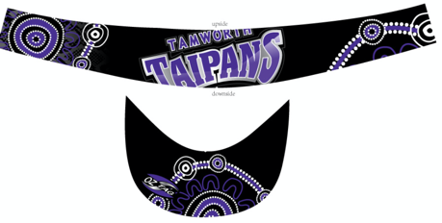 | $20
HOODIE | 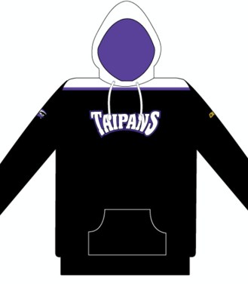 | $60
MUSCLE T | 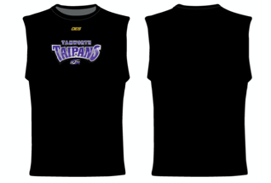  Grey marle not black | $30
SOCKS | 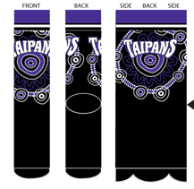 | $15

