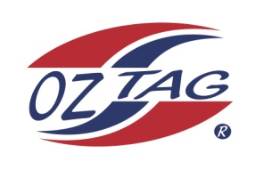
2021 TAMWORTH TAIPANS

UNDER 16 BOYS
Congratulations to the following players selected in the Tamworth Taipans
16’s Boys Junior Oztag Representative TEAM for 2021.
BOYS 16’s
Bailey | Wills
Bailey | Betts
Bailey | Simpson
Bradyn | Hamilton
Braydon | Allan
Brodhi | Davis
Cameron | Smith
Coben | Battle
Jack | Edser
Jacob | Antzakles
Jaice | Tiberi
Matthew | Brindley
Nathaniel | Follington
Nicholas | Driscoll
Robbie | Lay
Talyn | Hallford
SHADOW Players – not in order
Brody | Ferguson
Jake | Lace
Sebastian | Lawler
Braith | Patterson

- Coach: Brett Follington Assistant Coach: Damien Allan
- Manager: Donna Follington – 0409 779 466

- Congratulations, you have been selected in the Taipans Junior Oztag Representative TEAM to represent at the 2021 NSW Junior State Cup on Friday 12th, Saturday 13th and Sunday 14th February, 2021 to be held at Coffs Harbour.

- Please contact your Manager to accept your position in the team (Includes Shadows) by Wednesday 28th October. Player Registration is $200. 1st Payment of $100 is due 8th November (first training session) online or to your manager. 2nd Payment $100 is due 30th November.

- Rep Pack & Code of Conduct Form are on the Website. Please sign COC & give to your Manager ASAP.

- Compulsory training starts Sunday 8th November. Your Manager will be in touch regarding times.

