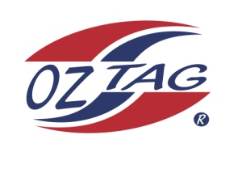
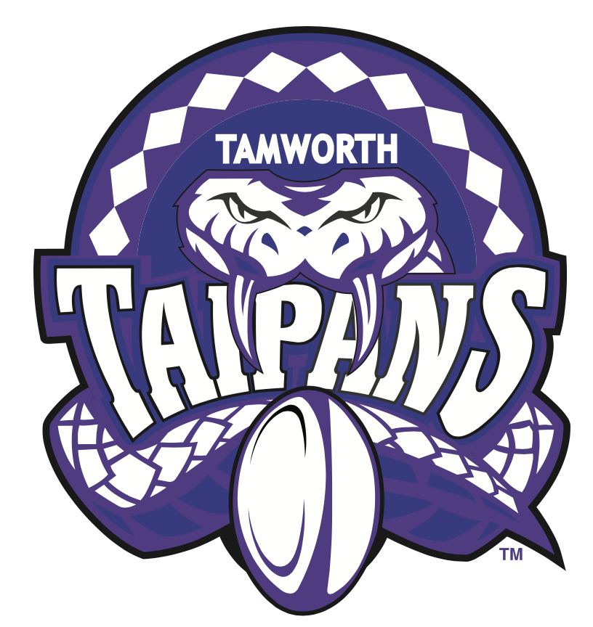
2021 TAMWORTH TAIPANS

UNDER 15 GIRLS

Congratulations to the following players selected in the Tamworth Taipans
15’s Girls Junior Oztag Representative TEAM for 2021.

GIRLS 15’s
Emily | Ryan
Grace | Shanley
Imogen | Smith
Isabella | Green
Jayda | Simpson
Kasey | Fulwood
Kyra | Detmers
Lauren | Daye
Lucy | Allen
Rhiannah | Hunt
Siennah-mae | Booby
Sophie | Weekes
Tarnee | Ingram
Tomi | Gavin
Violet | Nicholson
Zoe | Hartigan
SHADOW PLAYERS – not in order
Layla | Vine
Talia | Woolfe

- Coach: Geoff Sharpe
- Manager: Natasha Ingram – 0407 210 875

- Congratulations, you have been selected in the Taipans Junior Oztag Representative TEAM to represent at the 2021 NSW Junior State Cup on Friday 12th, Saturday 13th and Sunday 14th February, 2021 to be held at Coffs Harbour.

- Please contact your Manager to accept your position in the team (Includes Shadows) by Wednesday 28th October. Player Registration is $200. 1st Payment of $100 is due 8th November (first training session) online or to your manager. 2nd Payment $100 is due 30th November.

- Rep Pack & Code of Conduct Form are on the Website. Please sign COC & give to your Manager ASAP.

- Compulsory training starts Sunday 8th November. Your Manager will be in touch regarding times.

