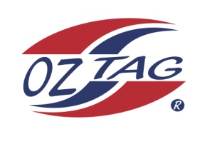
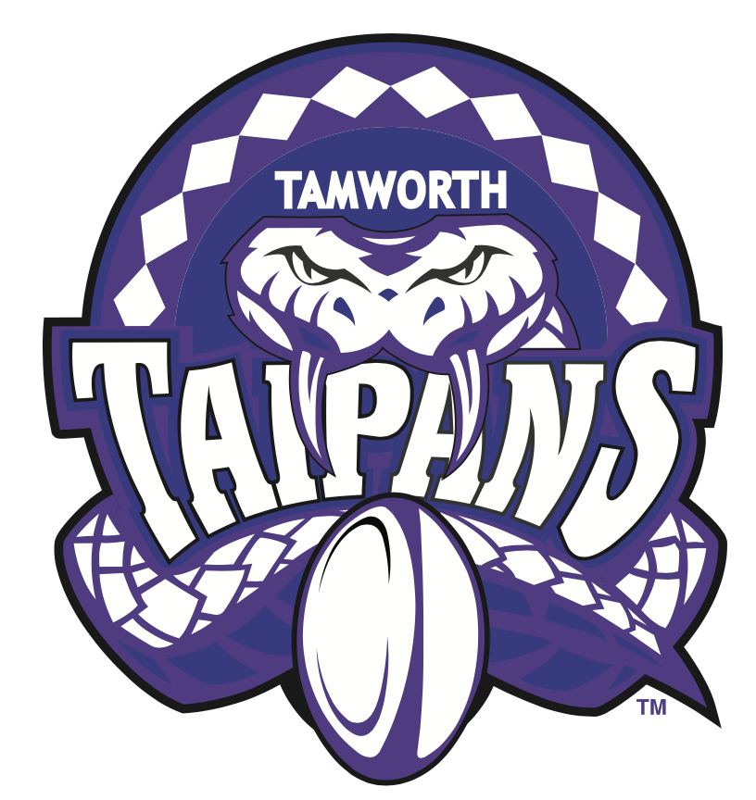
2021 TAMWORTH TAIPANS

UNDER 14 GIRLS

Congratulations to the following players selected in the Tamworth Taipans
14’s Girls Junior Oztag Representative TEAM for 2021.

GIRLS 14’s
Bindi | Isaac
Breanna | Allan
Charlotte | Bird
Elle | Beaumont
Emily | Dietrich
Indy | Brazier
Indyannah | Craigie
Kiana | Pund
Kyanna | Skuthorpe
Lahra | Avard
Lillian | Rapley
Maddison | Higgison
Makenna | Barnett-Suey
Maya | Patterson
Shelby | Rapley
Tylana | Lamb

- Coach: Krystal Lamb
- Manager: Melissa Pund – 0476 783 377

- Congratulations, you have been selected in the Taipans Junior Oztag Representative TEAM to represent at the 2021 NSW Junior State Cup on Friday 12th, Saturday 13th and Sunday 14th February, 2021 to be held at Coffs Harbour.

- Please contact your Manager to accept your position in the team (Includes Shadows) by Wednesday 28th October. Player Registration is $200. 1st Payment of $100 is due 8th November (first training session) online or to your manager. 2nd Payment $100 is due 30th November.

- Rep Pack & Code of Conduct Form are on the Website. Please sign COC & give to your Manager ASAP.

- Compulsory training starts Sunday 8th November. Your Manager will be in touch regarding times.

