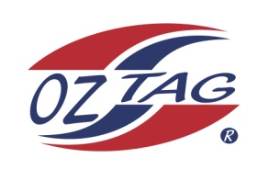
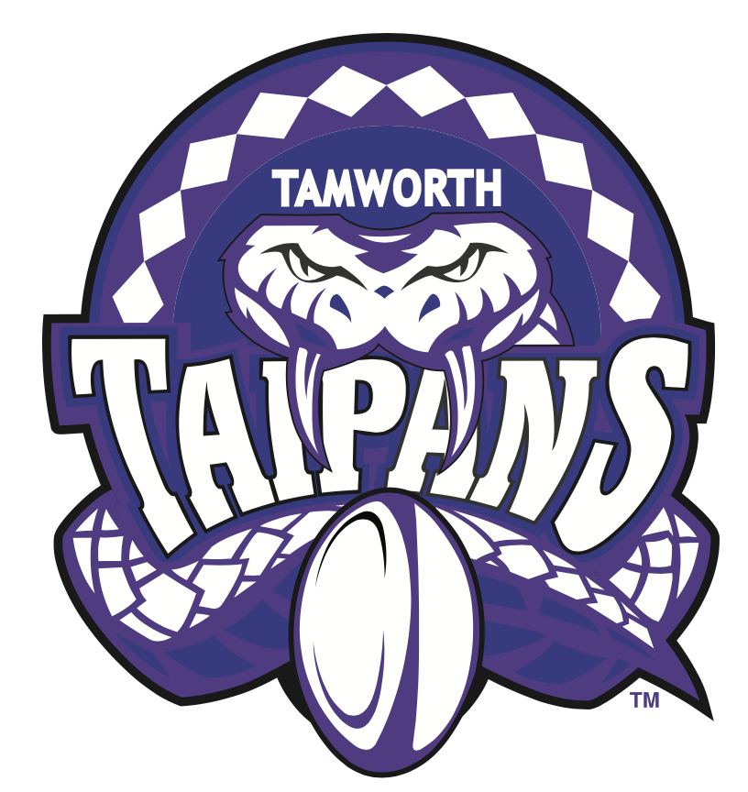
2021 TAMWORTH TAIPANS

UNDER 14 BOYS

Congratulations to the following players selected in the Tamworth Taipans
14’s Boys Junior Oztag Representative TEAM for 2021.

BOYS 14’s
Billy | Daly
Coby | Single
Fletcher | Panton
Harry | Gill
Hugh | Burnett
Jack | Toole
Josh | Beard
Leif | Dietrich
Nicholas | Green
Oscar | Turner
Robert | Naden
Robert | Murphy
Seth | Pearson
Toby | McIlveen
Toby | Robinson
Traie | Nean-Bell
SHADOW Players – not in order
Bryce | Walsh
Deagan | Sippel

Coach: Adam Single
Manager: Skye Single - 0417 444 661
- Congratulations, you have been selected in the Taipans Junior Oztag Representative TEAM to represent at the 2021 NSW Junior State Cup on Friday 12th, Saturday 13th and Sunday 14th February, 2021 to be held at Coffs Harbour.

- Please contact your Manager to accept your position in the team (Includes Shadows) by Wednesday 28th October. Player Registration is $200. 1st Payment of $100 is due 8th November (first training session) online or to your manager. 2nd Payment $100 is due 30th November.

- Rep Pack & Code of Conduct Form are on the Website. Please sign COC & give to your Manager ASAP.

- Compulsory training starts Sunday 8th November. Your Manager will be in touch regarding times.

