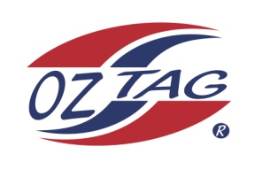
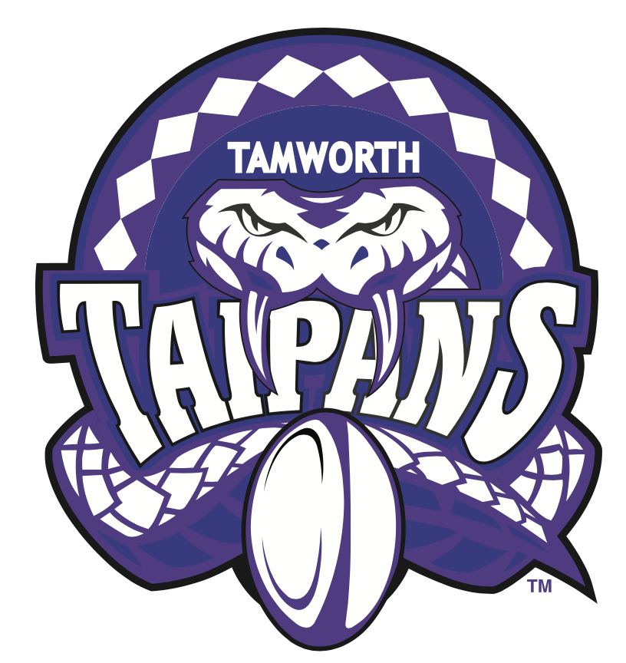
2021 TAMWORTH TAIPANS

UNDER 12 BOYS

Congratulations to the following players selected in the Tamworth Taipans
12’s Boys Junior Oztag Representative TEAM for 2021.

BOYS 12’s
Brody | Lace
Connor | Craig
Evan | Morrison
Harry | Hickey
Haydon | Allan -Saunders
Henry | Gilbert
Issac | Stackman
Izaiah | Craigie
Kobhan | Nean
Luca | Johnson
Nalani | Nean
Parker | O’Neile
Riley | Daly
Thomas | Ryan
Trey | Loveday
William | Green
SHADOW Players – Not in order
Kobi | McMaster
Noah | Barnett-Suey

- Coach: Matt Nean & Geoff Suey
- Manager: Kirsty O’Neile – 0408 762 032

- Congratulations, you have been selected in the Taipans Junior Oztag Representative TEAM to represent at the 2021 NSW Junior State Cup on Friday 12th, Saturday 13th and Sunday 14th February, 2021 to be held at Coffs Harbour.

- Please contact your Manager to accept your position in the team (Includes Shadows) by Wednesday 28th October. Player Registration is $200. 1st Payment of $100 is due 8th November (first training session) online or to your manager. 2nd Payment $100 is due 30th November.

- Rep Pack & Code of Conduct Form are on the Website. Please sign COC & give to your Manager ASAP.

- Compulsory training starts Sunday 8th November. Your Manager will be in touch regarding times.

