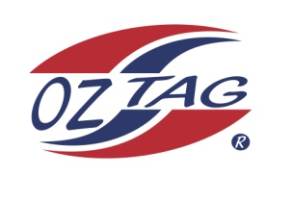
2021 TAMWORTH TAIPANS

UNDER 11 GIRLS

Congratulations to the following players selected in the Tamworth Taipans
11’s Girls Junior Oztag Representative TEAM for 2021.

GIRLS 11’s
Anika | Boney
Brodie | Burrows
Ebony | Pepperell
Holly | McIlveen
Isabel | O'Connell
Jacinta | Hoffman
Marley | Cowley
Marlie | Wilson
Mia | Naden
Natalie | Nean
Phoebe | Jobson
Samaya | Davis
Sienna | Caslick
Summar | Barnett

- Coach: Todd Wilson
- Manager: Liz Kelly – 0422 791 029

- Congratulations, you have been selected in the Taipans Junior Oztag Representative TEAM to represent at the 2021 NSW Junior State Cup on Friday 26th, Saturday 27th and Sunday 28th February, 2021 to be held at The Crest Sporting Complex, Bass Hill (Sydney).

- Please contact your Manager to accept your position in the team (Includes Shadows) by Wednesday 28th October. Player Registration is $200. 1st Payment of $100 is due 8th November (first training session) online or to your manager. 2nd Payment $100 is due 30th November.

- Rep Pack & Code of Conduct Form are on the Website. Please sign COC & give to your Manager ASAP.

- Compulsory training starts Sunday 8th November. Your Manager will be in touch regarding times.

