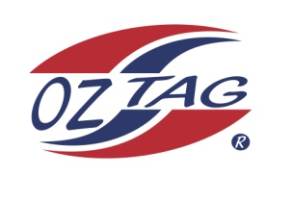
2021 TAMWORTH TAIPANS

UNDER 11 BOYS

Congratulations to the following players selected in the Tamworth Taipans
11’s Boys Junior Oztag Representative TEAM for 2021.

BOYS 11’s
Bradie | Hatch
Brodie | Hatch
Bryce | Reidsmith
Chase | Patterson
Connor | Matthews
Dennis | Nean - Kelly
Henry | Turner
Jace | Single
Jacob | Howarth
Jayden | Baker
Levi | Gebadi
Lewis | Crough
Zaiden | Kelly
Zane | Perrett

- Coach: Zach Hatch & Abby Schmiedel
- Manager: Andrew Baker – 0403 262 255

- Congratulations, you have been selected in the Taipans Junior Oztag Representative TEAM to represent at the 2021 NSW Junior State Cup on Friday 26th, Saturday 27th and Sunday 28th February, 2021 to be held at The Crest Sporting Complex, Bass Hill (Sydney).

- Please contact your Manager to accept your position in the team (Includes Shadows) by Wednesday 28th October. Player Registration is $200. 1st Payment of $100 is due 8th November (first training session) online or to your manager. 2nd Payment $100 is due 30th November.

- Rep Pack & Code of Conduct Form are on the Website. Please sign COC & give to your Manager ASAP.

- Compulsory training starts Sunday 8th November. Your Manager will be in touch regarding times.

