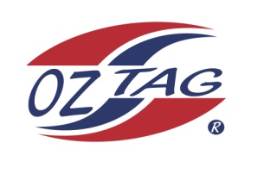
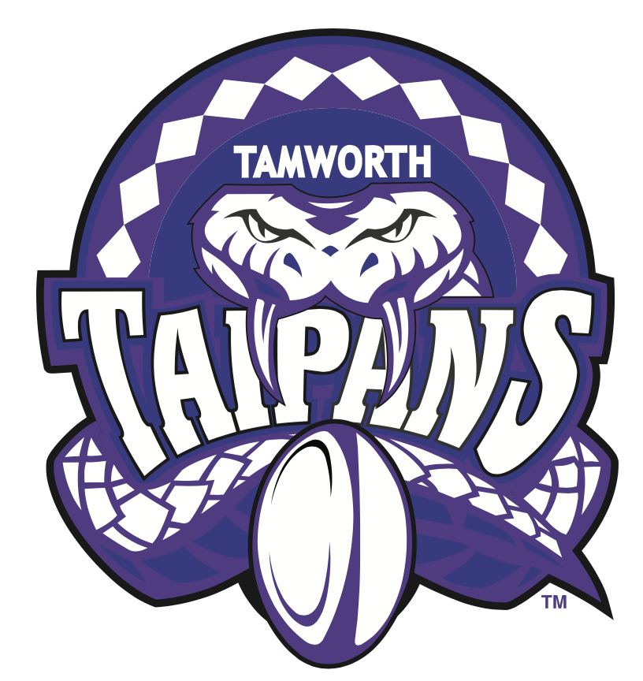
2021 TAMWORTH TAIPANS

UNDER 10 BOYS

Congratulations to the following players selected in the Tamworth Taipans
10’s Boys Junior Oztag Representative TEAM for 2021.

BOYS 10’s
Ashton | Jones
Brooklyn | Le Brocq-Watton
Chayse | Riley
Cooper | Smith
Easton | Battle
Eli | Harrison
Gilbert | Riley
Jaiden | Wright
Jett | Martin
Kade | Crittenden
Kalen | Loveday
Mathew | Murphy
Maximus | Thompson
Mitch | Weekes
Parker | Beaton
Tyler | O’Neile

- Coach: James Cooper & Andrew Loveday
- Manager: Jon Weekes – 0429 400 789

- Congratulations, you have been selected in the Taipans Junior Oztag Representative TEAM to represent at the 2021 NSW Junior State Cup on Friday 26th, Saturday 27th and Sunday 28th February, 2021 to be held at The Crest Sporting Complex, Bass Hill (Sydney).

- Please contact your Manager to accept your position in the team (Includes Shadows) by Wednesday 28th October. Player Registration is $200. 1st Payment of $100 is due 8th November (first training session) online or to your manager. 2nd Payment $100 is due 30th November.

- Rep Pack & Code of Conduct Form are on the Website. Please sign COC & give to your Manager ASAP.

- Compulsory training starts Sunday 8th November. Your Manager will be in touch regarding times.

