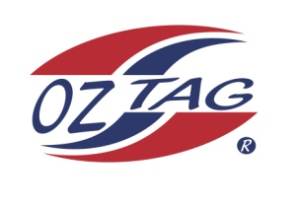
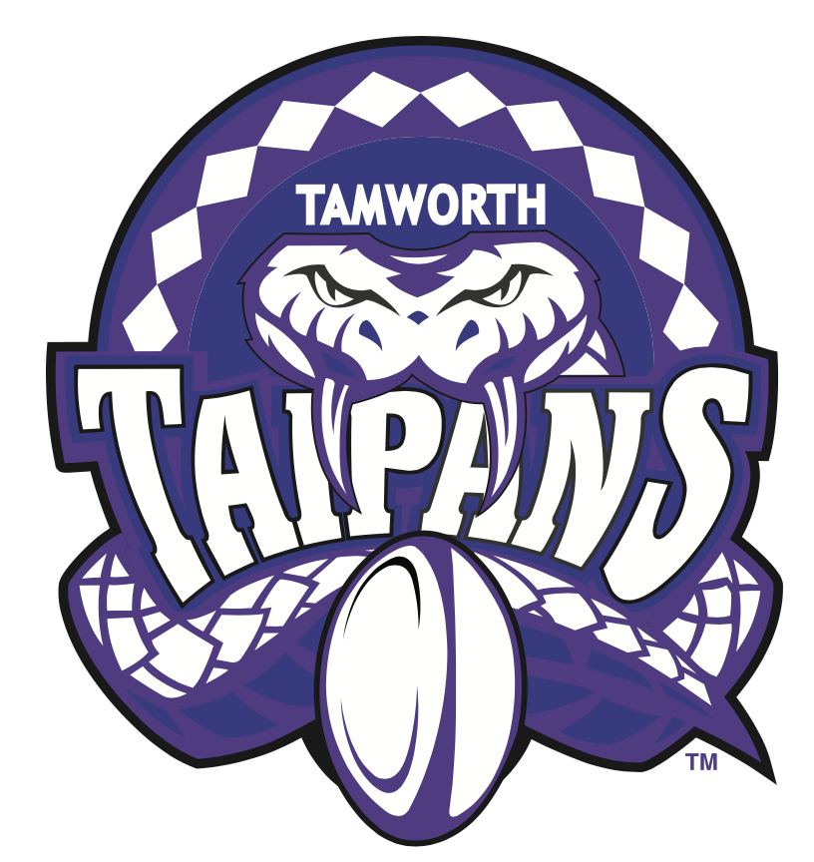
2020 TAMWORTH TAIPANS

UNDER 14 GIRLS
Congratulations to the following players selected in the Tamworth Taipans
14 Girls Junior Oztag Representative TEAM for 2020.

GIRLS 14
BOOBY | Sienna
CONSTABLE | Jayda
DAYE | Lauren
DETMERS | Kyra
FULWOOD | Kasey
GREEN | Isabella
HARTIGAN | Zoe
INGRAM | Tarnee
RYAN | Emily
SHANLEY | Grace
SIMPSON | Jayda
SMITH | Imogen
WEEKES | Sophie
WOOLFE | Tahlia

IMPORTANT INFORMATION
- Coach: Geoff Sharpe
- Assistant Coach Steph Fulwood
- Manager: Natasha Ingram

- Congratulations, you have been selected in the Taipans Junior Oztag Representative TEAM to represent at the 2020 NSW Junior State Cup from Friday 7th Feb – 9th Feb to be held at Coffs Harbour.

- All players MUST pay the balance of fees, $180 ONLINE or to the manager using the Active Kids Voucher and cash by Sunday December 1st.

- Complete the Rep Player package (print off website), and submit by Sunday Dec 1st..

- Compulsory trainings are held each Sunday morning in Term 4. All players are expected to attend all training sessions scheduled. Coaches may decide to add an additional training through the week closer to the tournament.

- See ‘State Cup’ tab for further details on the website, www.tamworthjunioroztag.com.au

