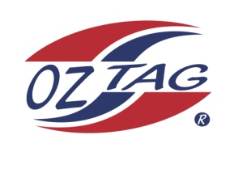
2020 TAMWORTH TAIPANS

UNDER 13 GIRLS
Congratulations to the following players selected in the Tamworth Taipans
13 Girls Junior Oztag Representative TEAM for 2020.

GIRLS 13
ALLAN | Breanna
BARNETT-SUEY | Makenna
BONEY | Delika
CRAIGIE | Indy
DIETRICH | Emily
HOWARTH | Isabella
LAMB | Tylana
MACLEAN | Aspen
PATTERSON | Maya
PERRETT | Mackenzie
PUND | Kiana
RAPLEY | Lillian
RAPLEY | Shelby
SCOTT | Mackenzie
SKATHORPE | Kyanna
STACKMAN | Brigette
Shadow Players
BETTS | Zahlee
HIGGISSON | Maddison

IMPORTANT INFORMATION
- Co-Coach: Natasha Allan & Krystal Lamb

- Congratulations, you have been selected in the Taipans Junior Oztag Representative TEAM to represent at the 2020 NSW Junior State Cup from Friday 7th Feb – 9th Feb to be held at Coffs Harbour.

- All players MUST pay the balance of fees, $180 ONLINE or to the manager using the Active Kids Voucher and cash by Sunday December 1st.

- Complete the Rep Player package (print off website), and submit by Sunday Dec 1st

- Shadow Players are invited to continue training, but there is no initial cost, they must be prepared to pay the full cost and move into the team if there is a withdrawal.

- Compulsory trainings are held each Sunday morning in Term 4. All players are expected to attend all training sessions scheduled. Coaches may decide to add an additional training through the week closer to the tournament.

- See ‘State Cup’ tab for further details on the website, www.tamworthjunioroztag.com.au

