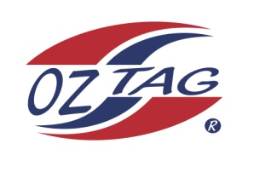
2020 TAMWORTH TAIPANS

UNDER 13 BOYS

Congratulations to the following players selected in the Tamworth Taipans
13 Boys Junior Oztag Representative TEAM for 2020.

BOYS 13
BEARD | Josh
BURNETT | Hugh
CROWELL | Harry
DALEY | Billy
DIETRICH | Leif
EATHER | Archie
GILL | Harry
GREEN | Nick
MCILVEEN | Toby
PANTON | Fletcher
PEARSON | Seth
SINGLE | Coby
SIPPEL | Deagan
TOOLE | Jack
TURNER | Oscar
WALSH | Bryce
Shadow Players
1.Bradley Cruickshank 2. Ryan Rankin | 3. Kyan Martin 4.Harrison Shaw

IMPORTANT INFORMATION
- Coach: Adam Single
- Manager: Skye Single
- Congratulations, you have been selected in the Taipans Junior Oztag Representative TEAM to represent at the 2020 NSW Junior State Cup from Friday 7th Feb – 9th Feb to be held at Coffs Harbour.

- All players MUST pay the balance of fees, $180 ONLINE or to the manager using the Active Kids Voucher and cash by Sunday December 1st.

- Complete the Rep Player package (print off website), and submit by Sunday Dec 1st..

- Shadow Players and players not selected are encouraged to continue to attend training for skill development.

- Compulsory trainings are held each Sunday morning in Term 4. All players are expected to attend all training sessions scheduled. Coaches may decide to add an additional training through the week closer to the tournament.

- See ‘State Cup’ tab for further details on the website, www.tamworthjunioroztag.com.au

