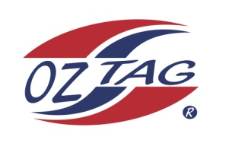
2020 TAMWORTH TAIPANS

UNDER 11 GIRLS
Congratulations to the following players selected in the Tamworth Taipans
11 Girls Junior Oztag Representative TEAM for 2020.

GIRLS 11
BIRD | Sarah
CARTAN | Lara
CASHMAN | Brooke
DIETRICH | Grace
DOWNEY | Sarah
HATCH | Ella
LAHRS | Macey
PARKES | Maddy
PEPPERELL | Sienna
REID | Shayliana
RULE | Lillian
SHIELDS | Hannah
SMITH | Miley
SULLIVAN | Zoe
THOMAS | Layla
WALSH | Evy

IMPORTANT INFORMATION
- Coach: Tim Walsh
- Manager: Tiff Walsh

- Congratulations, you have been selected in the Taipans Junior Oztag Representative TEAM to represent at the 2020 NSW U9-U11 Junior State Cup on Friday 22nd, Saturday 23rd and Sunday 24th February, 2019 to be held at The Crest Sporting Complex, Bass Hill.

- All players MUST pay the balance of fees, $180 ONLINE or to your manager the Active Kids Voucher and cash by Sunday December 1st.

- Complete the Rep Player package (print off website), and submit by Sunday 1st Dec

- Shadow Players are invited to continue training, but there is no initial cost, they must be prepared to pay the full cost and move into the team if there is a withdrawal.

- Compulsory trainings are held each Sunday morning in Term 4. All players are expected to attend all training sessions scheduled. Coaches may decide to add an additional training through the week closer to the tournament.

- See ‘State Cup’ tab for further details on the website, www.tamworthjunioroztag.com.au

