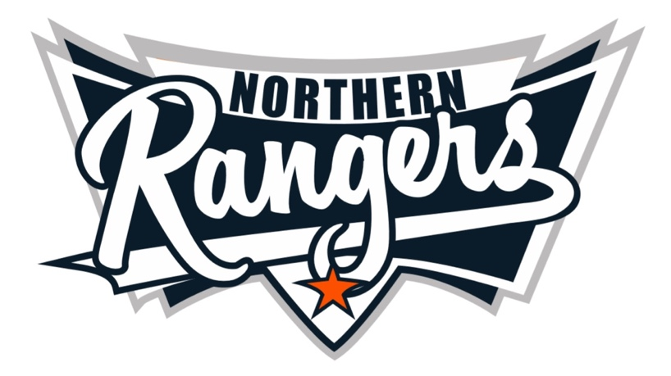

NORTHERN RANGERS JUNIOR OZTAG 2020
------------------------------------------------------
REPRESENTATIVE INFORMATION
Congratulations on your selection and welcome to the Northern Rangers Junior Oztag Representative Team. We hope you enjoy your experience playing representative Oztag at the 2020 National Championships.
Good luck!

There a number of expectations in which the combined Associations of Tamworth, Port Macquarie and Warialda expect of players, parents and officials in the lead up and throughout the tournament in Coffs Harbour.

- Tournament dates are: Friday 16th October to Sunday 18th October, 2020 and is held at the C-Ex Coffs International Stadium, Stadium Drive, Coffs Harbour. Parents are to book their accommodation, and organise travel to and from Coffs Harbour.
- The Registration, Gear Order and Code of Conduct Form is to be completed and returned to your Team Manager no later than Monday 10th August.
- The Player Registration fee is $200 per player. This includes tournament fees, uniform, and admin levy. (See information sheet for varied cost based on merchandise requirements)
- Payment is non-refundable, (although registration fee, $80 will be returned). If tournament cancelled after uniform orders are taken, players will be required to pay and keep uniform.
- Due to Covid-19 guidelines, numerous Rangers tents will be established throughout the precinct. When leaving each day, it is each team’s responsibility to clean up their rubbish from the tent area.
- Players are to respect the game and be supportive of their team mates, coach and manager at all times.
- Players are to respect that coaches volunteer their time, and are required to attend all training sessions. Players should arrive at training 10 minutes beforehand. Any player that continues to be late or absent can have their position revoked.
- Up to date information will be posted to all relevant association websites and social media sites.

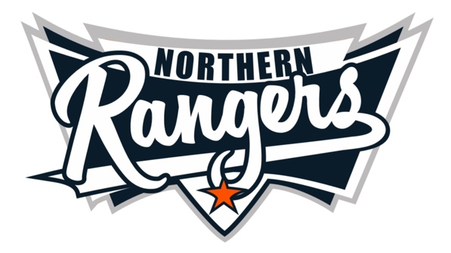
NORTHERN RANGERS
---------------------------------------------
CODE OF CONDUCT 2020

- Players and officials are to adhere to all tournament rules at all times.
- Never engage in disrespectful conduct of any sort including profanity, sledging, obscene gestures, offensive remarks, trash talking, taunting or other actions that are demeaning to your team mates, opposition players, officials or supporters.
- Players and officials are to accept the referees’ decision, and never argue.
- Recognise that many officials, coaches and referees are volunteers who give up their time to provide their services. Treat them with the utmost respect.
- Parents and supporters are to behave! Unsportsmanlike language, harassment or aggressive behaviour will not be tolerated.
- Officials are to conduct themselves in a manner at all times and in all situations, that shows leadership, respect for the game and the rules, and respect for those that are involved in the game – players, officials, volunteers and the referees.
- Coaches or Managers are to escalate any issues concerning the tournament to Katrina Davis, who in turn will resolve with the Tournament Director. No official is to directly engage Australian Oztag.
- Please do not comment on any form of social media on anything relative to the tournament, teams, officials or the running there of.
- The production and distribution of any unauthorised apparel is forbidden.
- Any representative player who withdraws from the squad; all replacements must be approved by the Committee.

We are responsible for the conduct of our association. Breaches to the above conduct will result in penalties, including but not limited to:

Suspension of a player, parent or official from the upcoming Oztag Summer Competition.
Suspension of a player, parent or official for the following Junior Nationals and/or Junior State Cup (2020)
These penalties are in addition to any penalty which may be imposed by NSW Oztag or Australian Oztag.

___________________________________________________________________
Name and Signature of Player/ or Official TEAM Date

___________________________________________________________________
Name and Signature of Parent/ or Witness Date

Players, and parents and Officials are to sign and return this form to their Team Manager. Team Managers are to submit their forms to the Region Co-ordinator, Katrina Davis. Any players or officials who fail to sign and return the form will result in your position being revoked.

