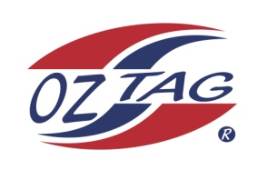
2020 TAMWORTH TAIPANS

UNDER 11 BOYS
Congratulations to the following players selected in the Tamworth Taipans
11 Boys Junior Oztag Representative TEAM for 2020.

BOYS 11
ALLAN-SAUNDERS | Haydon
BARNETT-SUEY | Noah
CRAIG | Connor
CRAIGIE | Izaiah
DALEY | Riley
GREEN | Will
HICKEY | Harry
JOHNSON | Luca
LACE | Brody
McMURTRIE | Charlie
McMASTER | Kobi
MILLGATE | Tremayne
MORRISON | Evan
NEAN | Kobhan
O’NEILE | Parker
STACKMAN | Isaac
Shadow Player
NEAN | Nalani

IMPORTANT INFORMATION
- Coach: Geoff Suey
- Manager: Sarah Green
- Congratulations, you have been selected in the Taipans Junior Oztag Representative TEAM to represent at the 2020 NSW U9-U11 Junior State Cup on Friday 22nd, Saturday 23rd and Sunday 24th February, 2019 to be held at The Crest Sporting Complex, Bass Hill.

- All players MUST pay the balance of fees, $180 ONLINE or to your manager the Active Kids Voucher and cash by Sunday December 1st.

- Complete the Rep Player package (print off website), and submit by Sunday 1st Dec

- Compulsory trainings are held each Sunday morning in Term 4. All players are expected to attend all training sessions scheduled. Coaches may decide to add an additional training through the week closer to the tournament.

- See ‘State Cup’ tab for further details on the website, www.tamworthjunioroztag.com.au

