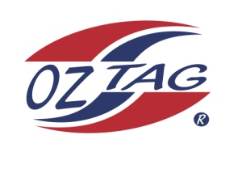
2020 TAMWORTH TAIPANS

UNDER 9 GIRLS
Congratulations to the following players selected in the Tamworth Taipans
9 Girls Junior Oztag Representative TEAM for 2020.

GIRLS 9
ALLAN | Layla
BARRETT | Emily
CLEGG | Olivia
CLEGG | Ruby
FERGUSON | Dakota
FERGUSON | Sienna
LAMB | Kelsea
MARTIN | Sophie
MORRISON | Regan
MUNN | Ryley
RAMIREZ | Armani
ROWLING-WRIGLEY | Coby
SINGLE | Indy
THOMAS | Harper
WALSH | Stella
WATSON | Mia

IMPORTANT INFORMATION
- Coach: Richie Clegg
- Manager: Bel Clegg

- Congratulations, you have been selected in the Taipans Junior Oztag Representative TEAM to represent at the 2020 NSW U9-U11 Junior State Cup on Friday 22nd, Saturday 23rd and Sunday 24th February, 2019 to be held at The Crest Sporting Complex, Bass Hill.

- All players MUST pay the balance of fees, $180 ONLINE or to your manager the Active Kids Voucher and cash by Sunday December 1st.

- Complete the Rep Player package (print off website), and submit by Sunday 1st Dec

- Compulsory trainings are held each Sunday morning in Term 4. All players are expected to attend all training sessions scheduled. Coaches may decide to add an additional training through the week closer to the tournament.

- See ‘State Cup’ tab for further details on the website, www.tamworthjunioroztag.com.au

