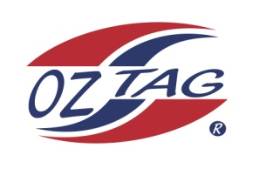
2020 TAMWORTH TAIPANS

UNDER 9 BOYS

Congratulations to the following players selected in the Tamworth Taipans
9 Boys Junior Oztag Representative TEAM for 2020.

BOYS 9
BATTLE | Easton
CLINTON | Jack
CRITTENDEN | Kade
JONES | Ashton
LAHRS | Bailin
LE BROCQ WATTON | Brooklyn
LOVEDAY | Kalen
MILLGATE | Mason
O’NEILE | Tyler
RILEY | Chaise
STRONG | Kade
THOMPSON | Max
VAN AANHOLT | Ben
WILSON | Koby
Shadow Players
BLISS | Brodie
MUNRO | Zeph

IMPORTANT INFORMATION
- Coach: Tom Lahrs
- Manager: Felicity van Aanholt

- Congratulations, you have been selected in the Taipans Junior Oztag Representative TEAM to represent at the 2020 NSW U9-U11 Junior State Cup on Friday 21st, Saturday 22nd and Sunday 23rd February, 2020 to be held at The Crest Sporting Complex, Bass Hill.

- All players MUST pay the balance of fees, $180 ONLINE or to the manager using the Active Kids Voucher and cash by Sunday December 1st.

- Complete the Rep Player package (print off website), and submit by Sunday 1st December.

- Shadow Players are invited to continue training, but there is no initial cost, they must be prepared to pay the full cost and move into the team if there is a withdrawal.

- Compulsory trainings are held each Sunday morning in Term 4. All players are expected to attend all training sessions scheduled. Coaches may decide to add an additional training through the week closer to the tournament.

- See ‘State Cup’ tab for further details on the website, www.tamworthjunioroztag.com.au

