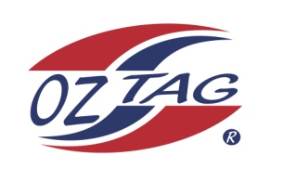
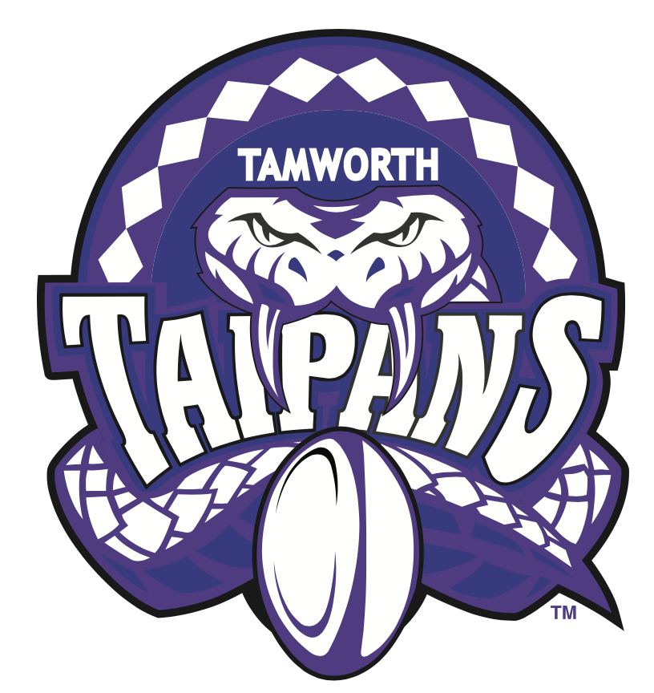
2020 TAMWORTH TAIPANS

UNDER 17 GIRLS
Congratulations to the following players selected in the Tamworth Taipans
17 Girls Junior Oztag Representative TEAM for 2020.

GIRLS 17
BARNETT-SUEY | Dakotah
BOWDEN | Abbey
BYNGE | Holly
DEJONG | Lara
DIXON | Kamyra
GILL | Sarah
HATCH | Chloe
HORNIMAN | Georgia
JOHNSON | Ryli
NEW | Ellie
PORTER | Phoebe
RYAN | Abbey
SHANLEY | Chloe
SMITH | Amity
WHITTEMORE | Olivia
Shadow Player
SMITH | Ella

IMPORTANT INFORMATION
- Coach: Steve Porter
- Assistant Coach Paris Knox
- Manager: Alex New

- Congratulations, you have been selected in the Taipans Junior Oztag Representative TEAM to represent at the 2020 NSW Junior State Cup from Friday 7th Feb – 9th Feb to be held at Coffs Harbour.

- All players MUST pay the balance of fees, $180 ONLINE or to the manager using the Active Kids Voucher and cash by Sunday December 1st.

- Complete the Rep Player package (print off website), and submit by Sunday Dec 1st..

- Compulsory trainings are held each Sunday morning in Term 4. All players are expected to attend all training sessions scheduled. Coaches may decide to add an additional training through the week closer to the tournament.

- See ‘State Cup’ tab for further details on the website, www.tamworthjunioroztag.com.au

