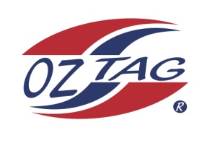
2020 TAMWORTH TAIPANS

UNDER 10 GIRLS
Congratulations to the following players selected in the Tamworth Taipans
10 Girls Junior Oztag Representative TEAM for 2020.

GIRLS 10
BONEY | Anika
CASLICK | Sienna
COWLEY | Marley
DEAN HOFFMAN | Jacinta
JOBSON | Phoebe
McILVEEN | Holly
MILLGATE | Aaliyah
NEAN | Nat
OCONNELL | Isabell
PEPPERELL | Ebony
WILSON | Marley

IMPORTANT INFORMATION
- Coach: Todd Wilson
- Manager: Liz Kelly

- Congratulations, you have been selected in the Taipans Junior Oztag Representative TEAM to represent at the 2020 NSW U9-U11 Junior State Cup on Friday 22nd, Saturday 23rd and Sunday 24th February, 2019 to be held at The Crest Sporting Complex, Bass Hill.

- All players MUST pay the balance of fees, $180 ONLINE or to your manager the Active Kids Voucher and cash by Sunday December 1st.

- Complete the Rep Player package (print off website), and submit by Sunday 1st Dec

- Shadow Players are invited to continue training, but there is no initial cost, they must be prepared to pay the full cost and move into the team if there is a withdrawal.

- Compulsory trainings are held each Sunday morning in Term 4. All players are expected to attend all training sessions scheduled. Coaches may decide to add an additional training through the week closer to the tournament.

- See ‘State Cup’ tab for further details on the website, www.tamworthjunioroztag.com.au

