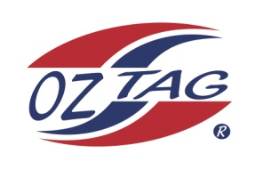
2019 TAMWORTH TAIPANS

UNDER 10 BOYS
Congratulations to the following players selected in the Tamworth Taipans
10 Boys Junior Oztag Representative TEAM for 2020.

BOYS 10
BAKER | Jayden
CROUGH | Lewis
GEBADI | Levi
HATCH | Bradie
HATCH | Brodie
HOWARTH | Jacob
KELLY | Zaiden
LAY | Corey
MATTHEWS | Connor
PATTERSON | Chase
PERRETT | Zane
RULE | Cooper
SINGLE | Jace
STRONG | Bowen
TURNER | Henry
Shadow Players*
KELLY | Jai
REID-SMITH | Bryce
WHEELER | Isaac

* PLEASE NOTE: 1 Player, based on Sunday 10th training is still to be selected from the shadows.
IMPORTANT INFORMATION
- Coach: Pat Strong
- Manager: Andrew Baker

- Congratulations, you have been selected in the Taipans Junior Oztag Representative TEAM to represent at the 2020 NSW U9-U11 Junior State Cup on Friday 22nd, Saturday 23rd and Sunday 24th February, 2019 to be held at The Crest Sporting Complex, Bass Hill.

- All players MUST pay the balance of fees, $180 ONLINE or to your manager the Active Kids Voucher and cash by Sunday December 1st.

- Complete the Rep Player package (print off website), and submit by Sunday 1st Dec

- Compulsory trainings are held each Sunday morning in Term 4. All players are expected to attend all training sessions scheduled. Coaches may decide to add an additional training through the week closer to the tournament.

- See ‘State Cup’ tab for further details on the website, www.tamworthjunioroztag.com.au

